Agile Sprint Planning & User Story Workshop
Restaurant Table Reservation and Management System
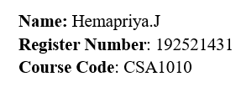
Prepared as an Agile software engineering planning document for the development of a system that enables customers to view restaurant availability, reserve tables, cancel reservations, and enables restaurant staff to manage tables and bookings.

Contents
1. Project Vision and Stakeholders
2. Product Scope and Assumptions
3. Epics and User Stories
4. Acceptance Criteria
5. Agile Workflow Diagram
6. Prioritized Product Backlog
7. Sprint 1 Backlog and Tasks
8. Story-Point Estimation and Justification
9. Definition of Done, Risks and Review Plan
10. Conclusion
11. Agile Process Model
Appendix A. Reference-Aligned System Analysis and Design

1. Project Vision and Stakeholders
Project vision: To provide a reliable and easy-to-use restaurant reservation platform that shows accurate table availability, lets customers make or cancel bookings quickly, and gives restaurant staff a single source of truth for tables, reservations, and daily capacity.
Business objectives:
- Reduce waiting time and manual phone-based booking work.
- Prevent double bookings by maintaining real-time table and reservation status.
- Improve customer convenience through clear availability, confirmation, and cancellation.
- Give restaurant staff simple operational controls for tables and bookings.
- Create an extensible foundation for future features such as payments, waitlists, analytics, and loyalty.

Key stakeholders

Stakeholder | Role / interest | Main success measure
Customers | Search availability, reserve, modify or cancel tables. | Fast, accurate, and trustworthy booking experience.
Restaurant staff | Create, update, confirm, and manage tables and bookings. | Fewer booking errors and clear daily visibility.
Restaurant manager / owner | Owns business rules, capacity, reports, and service quality. | Higher table utilization and better operational control.
Product owner | Prioritizes the backlog and accepts completed stories. | Maximum value delivered in each sprint.
Development team | Designs, builds, tests, and deploys the system. | Working, maintainable increments.
QA / test engineer | Validates functional, integration, and usability quality. | Defects found early; acceptance criteria satisfied.
System administrator | Maintains users, configuration, security, and support. | Secure and available service.

2. Product Scope and Assumptions
In scope for the initial product increment: customer availability search, table reservation, reservation confirmation, cancellation, staff table management, staff booking management, role-based access, and basic audit information.
Out of scope for Sprint 1: online payment, loyalty points, delivery ordering, advanced analytics, automated marketing campaigns, and multi-branch reporting. These may be considered in later releases after the core reservation flow is stable.
Assumptions: a restaurant has defined operating hours and table capacity; a reservation contains date, time, party size, customer details, and status; the system uses a single restaurant branch for the first release; and email or in-app notification can be represented by a notification service interface during development.

3. Epics and User Stories
Epic | Purpose | Representative stories
E1. Availability and Search | Show customers when and where tables are available. | US-01, US-02
E2. Reservation Lifecycle | Create, confirm, view, and cancel reservations. | US-03, US-04, US-05
E3. Table and Booking Operations | Allow staff to manage tables and bookings. | US-06, US-07
E4. Access and Notifications | Protect staff functions and keep users informed. | US-08, US-09
E5. Quality and Auditability | Provide traceability, validation, and safe operation. | US-10

4. Acceptance Criteria

US-01 – Availability and Search
As a customer, I want to enter a date, time, and party size, so that I can see suitable available tables before making a reservation.
Acceptance criteria:
- Given valid date, time, and party size, when I search, then the system displays tables or time slots that can accommodate the party.
- Given no suitable table is available, when I search, then the system displays a clear no-availability message and alternative time suggestions if available.
- Given invalid or incomplete search data, when I submit, then the system identifies the field that must be corrected and does not create a booking.
Priority: Must Have | Story points: 5

US-02 – Availability and Search
As a customer, I want to view table details and availability status, so that I can choose an appropriate table with confidence.
Acceptance criteria:
- Given a search result, when I open a table, then the system shows table identifier, capacity, location or type, and current availability status.
- Given a table is already reserved for the selected slot, when the results load, then it cannot be selected for a conflicting reservation.
- Given table data changes, when the customer refreshes the search, then the displayed status reflects the latest saved status.
Priority: Must Have | Story points: 3

US-03 – Reservation Lifecycle
As a customer, I want to reserve an available table, so that my visit is recorded and the restaurant can prepare for my arrival.
Acceptance criteria:
- Given an available table and valid customer details, when I confirm the booking, then the system creates a unique reservation with a pending or confirmed status.
- Given a successful reservation, when the transaction completes, then the customer sees the reservation reference, date, time, party size, and table.
- Given another customer takes the table before confirmation, when I attempt to confirm, then the system rejects the conflict and asks me to choose another option.
Priority: Must Have | Story points: 8

US-04 – Reservation Lifecycle
As a customer, I want to view my reservation details, so that I can check the booking information before visiting the restaurant.
Acceptance criteria:
- Given a valid reservation reference or authenticated customer account, when I request details, then the system shows the current reservation status and booking information.
- Given an unknown or unauthorized reference, when I request details, then the system does not reveal reservation data and shows a safe error message.
Priority: Should Have | Story points: 3

US-05 – Reservation Lifecycle
As a customer, I want to cancel my reservation, so that the table can be released when my plans change.
Acceptance criteria:
- Given an active reservation within the permitted cancellation window, when I confirm cancellation, then the status changes to cancelled and the table becomes available for the relevant slot.
- Given a cancellation request outside the allowed policy, when I submit it, then the system explains the restriction and does not silently cancel the booking.
- Given a successful cancellation, when the action completes, then the customer receives a cancellation confirmation.
Priority: Must Have | Story points: 5

US-06 – Table and Booking Operations
As a staff member, I want to create and update table records, so that the system matches the restaurant’s real seating layout and capacity.
Acceptance criteria:
- Given staff authorization, when I add a table with a unique identifier and capacity, then the table appears in the active table list.
- Given an existing table, when I update its capacity or status, then the new values are saved and visible in availability searches.
- Given a duplicate table identifier, when I save, then the system rejects the record and explains the duplication.
Priority: Must Have | Story points: 5

US-07 – Table and Booking Operations
As a staff member, I want to view and manage bookings by date and status, so that I can operate the restaurant efficiently.
Acceptance criteria:
- Given staff authorization, when I open the booking view, then I can filter bookings by date, time, status, and table.
- Given a booking, when staff confirm, seat, complete, or cancel it according to policy, then the status change is recorded and reflected in availability.
- Given a conflicting staff action, when it would create an overlapping booking, then the system blocks the action and displays the conflict.
Priority: Must Have | Story points: 8

US-08 – Access and Notifications
As a restaurant manager, I want role-based access, so that only authorized staff can change tables and bookings.
Acceptance criteria:
- Given a customer account, when it attempts to open staff functions, then access is denied.
- Given an authorized staff role, when it opens permitted functions, then the user can perform only the actions allowed for that role.
- Given repeated failed login attempts, when the security threshold is reached, then the system applies the configured protection and records the event.
Priority: Must Have | Story points: 5

US-09 – Access and Notifications
As a customer, I want a confirmation or cancellation notification, so that I have written evidence of my booking status.
Acceptance criteria:
- Given a reservation or cancellation succeeds, when the transaction completes, then a notification is queued with the correct reference and booking details.
- Given notification delivery fails, when the system detects the failure, then the booking remains consistent and the failure is logged for retry or staff review.
Priority: Should Have | Story points: 3

US-10 – Quality and Auditability
As a restaurant manager, I want important booking actions to be auditable, so that disputes and operational issues can be investigated.
Acceptance criteria:
- Given a create, update, confirm, seat, complete, or cancel action, when it succeeds, then the system records actor, timestamp, action, and affected reservation or table.
- Given an audit query by authorized staff, when filters are applied, then matching events are displayed without allowing records to be altered.
Priority: Could Have | Story points: 5

5. Agile Workflow Diagram
The following diagram connects the main customer journey with the restaurant staff workflow. It is placed here to show how an availability update flows back into the customer reservation experience.
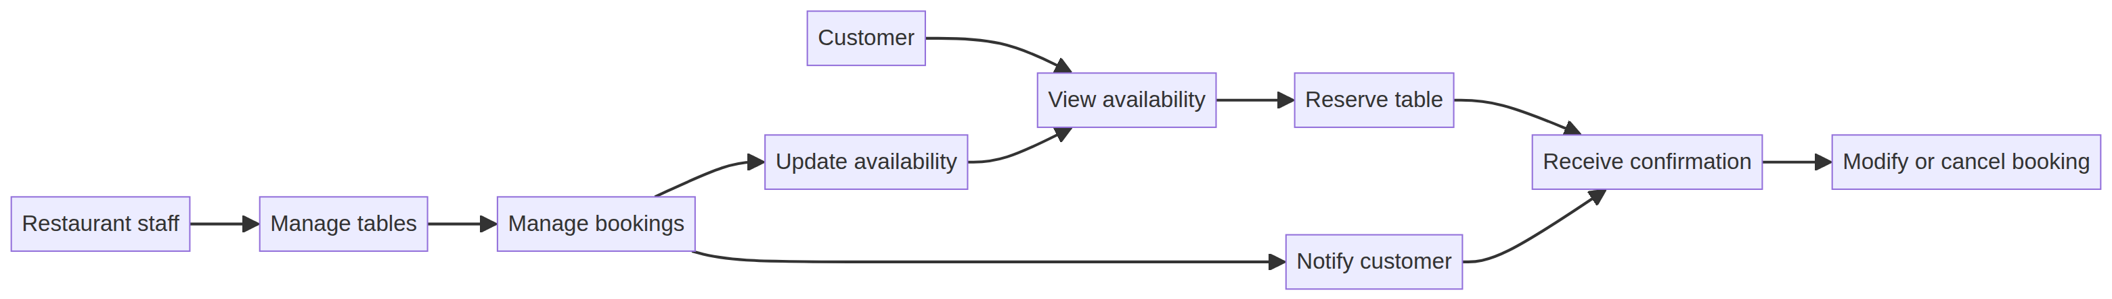
Figure 1. Customer and staff interaction flow for table reservations
The workflow supports the product vision by ensuring that table configuration and booking actions by staff update the same availability information used by customers. This reduces the risk of double booking and keeps the reservation lifecycle visible from search through cancellation or completion.

6. Prioritized Product Backlog
Prioritization uses the MoSCoW method supported by business value, customer impact, risk reduction, and dependency order. Stories needed to create a safe end-to-end reservation flow are placed before convenience or reporting enhancements.

Rank | Story | Backlog item | Priority | Dependency / rationale | Points
1 | US-06 | Create and update table records | Must Have | Foundation for valid capacity and availability data. | 5
2 | US-01 | Search availability | Must Have | Depends on table data; first customer-facing value. | 5
3 | US-02 | View table details | Must Have | Depends on availability search results. | 3
4 | US-03 | Create reservation | Must Have | Core business transaction; depends on availability. | 8
5 | US-08 | Role-based staff access | Must Have | Protects staff operations before wider use. | 5
6 | US-07 | Manage bookings by date and status | Must Have | Operational control; depends on reservation lifecycle. | 8
7 | US-05 | Cancel reservation | Must Have | Releases capacity and completes core lifecycle. | 5
8 | US-04 | View reservation details | Should Have | Improves customer self-service after booking exists. | 3
9 | US-09 | Notifications | Should Have | Improves trust; can use a service interface initially. | 3
10 | US-10 | Audit important actions | Could Have | Important for maturity but can follow core flow. | 5

7. Sprint 1 Backlog and Tasks
Sprint length: 2 weeks. Sprint goal: Deliver a secure, demonstrable vertical slice in which an authorized staff member can maintain tables and a customer can search availability and reserve one non-conflicting table.
Capacity assumption: one cross-functional team with a sustainable capacity of approximately 24 story points for the sprint. The selected backlog totals 21 points, leaving a small buffer for integration defects and refinement.
Selected story | Points | Actionable development tasks | Expected increment / evidence
US-06 – Manage tables | 5 | Design table data model; create add/edit table screens or endpoints; validate unique table ID and capacity; add unit tests; seed sample tables. | Staff can create and edit tables and the saved data appears in the table list.
US-01 – Search availability | 5 | Define search request and response; implement date/time/party-size validation; calculate suitable capacity; create customer search view; add service tests. | Customer can search a selected slot and see available or unavailable results.
US-02 – View table details | 3 | Add table detail view; expose capacity/type/status; disable conflicting selection; test refresh and status display. | Customer can inspect a result and select only a suitable available table.
US-03 – Create reservation | 8 | Design reservation schema; implement conflict check and transaction; create confirmation form; generate reference; add integration and negative tests. | Customer can complete a non-conflicting reservation and receive a reference.

Sprint task sequence
- Day 1–2: confirm examples, data model, API contracts, screen sketches, and test scenarios.
- Day 3–5: implement table management and availability search with unit tests.
- Day 6–8: implement table details and reservation transaction with conflict handling.
- Day 9: integrate customer and staff flows; run regression, usability, and security checks.
- Day 10: fix priority defects, prepare demonstration data, conduct Sprint Review and Retrospective.

Sprint dependencies and risks
Risk / dependency | Impact | Mitigation / owner
Unclear seating rules | Incorrect availability results. | Product owner confirms capacity, operating hours, and table-combination rules before development.
Concurrent booking requests | Double booking. | Development team uses an atomic conflict check and transaction test.
Staff permissions not defined | Unauthorized changes. | Product owner and technical lead agree role matrix before access story is accepted.
Notification provider unavailable | Customer may not receive message. | Keep notification behind an interface; preserve booking consistency and log delivery status.

8. Story-Point Estimation and Justification
Estimation technique: Planning Poker using Fibonacci-sized points (1, 2, 3, 5, 8, 13). The team compares each story with a reference story, discusses complexity, uncertainty, integration effort, and testing scope, and then agrees on the closest value. Points represent relative effort, not hours.
Reference | Story-point meaning | Example in this product
1–2 | Very small, low uncertainty, limited change. | Small display or validation adjustment.
3 | Small story with one main flow and modest testing. | View reservation details or table details.
5 | Moderate story with validation, persistence, and several tests. | Manage tables, search availability, cancel reservation.
8 | Large cross-layer story with transaction, conflict, and integration risk. | Create reservation or manage bookings.
13 | Very large or highly uncertain; should be split before commitment. | Multi-branch scheduling, payments, or advanced analytics.

Justification of Sprint 1 estimates: US-06 is 5 points because it combines persistence, validation, and staff-facing operations. US-01 is 5 points because it requires business rules for capacity and time-slot availability plus customer validation. US-02 is 3 points because it mainly presents existing table data with selection rules. US-03 is 8 points because it is the highest-risk transaction: it must validate customer input, prevent overlapping bookings under concurrent requests, persist the reservation, and return a reliable reference. The total of 21 points is appropriate for a two-week sprint with capacity reserved for integration and defect correction.

9. Definition of Done, Risks and Review Plan

Definition of Done
- Acceptance criteria are implemented and demonstrated with realistic examples.
- Code is peer reviewed and follows agreed naming, validation, and error-handling conventions.
- Unit, integration, and relevant UI tests pass; no unresolved high-severity defects remain.
- Data changes are safe, authorized, and covered by conflict or duplicate checks.
- The feature is documented sufficiently for a new team member or support user to understand it.
- The Product Owner accepts the story during the Sprint Review.

Sprint ceremonies
Ceremony | Participants | Purpose | Output
Sprint Planning | Product Owner, Scrum Master, Development Team | Clarify goal, select stories, identify dependencies, estimate tasks. | Sprint goal and Sprint Backlog.
Daily Scrum | Development Team | Inspect progress and raise impediments. | Updated plan for the next 24 hours.
Backlog Refinement | Product Owner and Development Team | Split, clarify, and re-estimate upcoming stories. | Ready, ordered backlog items.
Sprint Review | Stakeholders and Scrum Team | Demonstrate the working increment and collect feedback. | Accepted stories and feedback items.
Retrospective | Scrum Team | Inspect collaboration, process, and quality. | One or two measurable improvement actions.

10. Conclusion
The proposed Agile plan turns the restaurant reservation problem into a prioritized, testable, and incrementally deliverable product backlog. Sprint 1 focuses on the smallest valuable vertical slice: staff-maintained table data, customer availability search, table details, and a protected reservation transaction. The acceptance criteria make each story measurable, the dependency order reduces rework, and the 21-point commitment balances business value with delivery risk. Subsequent sprints can extend the lifecycle with cancellation, staff booking operations, notifications, auditing, and future enhancements such as payments or waitlists.

11. Agile Process Model
The Agile process model is an iterative and incremental approach in which the product is developed through repeated short cycles called sprints. Instead of waiting until the end of the project to deliver the complete system, the team delivers a tested and usable increment at the end of each sprint. Feedback from customers, restaurant staff, and the Product Owner is used to refine the next version of the product.
For the Restaurant Table Reservation and Management System, Agile is suitable because reservation rules, staff workflows, table availability needs, and notification expectations can become clearer as stakeholders review working features. The team can first deliver the core reservation flow and then improve it through later sprints.
Figure 19. Agile process model for the restaurant reservation project
The diagram shows the continuous Agile cycle. The Product Vision defines the business direction, while the Product Backlog stores epics, user stories, acceptance criteria, and improvement ideas. During Backlog Refinement, stories are clarified, split when necessary, estimated, and prioritized. Sprint Planning selects the highest-value ready stories and establishes a clear Sprint Goal.
During Development and Testing, the team designs, codes, integrates, and validates the selected stories. The result is a working Increment, such as a customer availability search or a conflict-safe table reservation. In the Sprint Review, the team demonstrates the increment to stakeholders and records feedback. The Sprint Retrospective then identifies improvements to collaboration, quality, estimation, and delivery. The feedback returns to the backlog or refinement cycle, so the product continuously evolves.
- Product Owner: prioritizes customer convenience, booking reliability, staff control, and business value.
- Scrum Master: supports the Agile process, removes impediments, and helps the team maintain a sustainable pace.
- Development Team: designs, develops, tests, integrates, and documents the reservation system.
- Customer and restaurant staff feedback: validates whether availability, reservation, cancellation, and table-management features are useful and understandable.
- Sprint Increment: each sprint ends with demonstrable functionality that satisfies its acceptance criteria and Definition of Done.
Example sprint cycle for the project: Sprint 1 can deliver table setup, availability search, table details, and reservation creation. Sprint 2 can add cancellation, reservation lookup, staff booking management, and role-based access. Sprint 3 can add notifications, audit history, reports, usability improvements, and broader test coverage. The exact scope may change after review feedback, which is a normal and valuable part of Agile planning.
Key benefits of using Agile for this system include early delivery of business value, regular stakeholder feedback, reduced risk of double booking through early testing, better visibility of progress, easier response to changing restaurant policies, and continuous improvement through retrospectives.

Appendix A – Reference-Aligned System Analysis and Design
This appendix incorporates the case-study material from the supplied reference into the Agile sprint-planning document. It connects the problem context, system requirements, design decisions, feasibility, database structure, testing strategy, and future scope to the product backlog and sprint plan already defined above.

A1. Introduction and Problem Statement
A Restaurant Table Reservation and Management System (RTRMS) is a web-based application that enables customers to check table availability, reserve a table for a selected date and time, and cancel a reservation when plans change. It also gives restaurant staff a centralized place to maintain table details, supervise bookings, and view customer information.
The system replaces handwritten registers and telephone-based bookings with a centralized, database-driven solution. A restaurant has a limited number of tables that must be shared among many customers in a time-sensitive environment. Manual booking forces staff to answer calls, inspect registers, and write entries while serving walk-in guests. This increases the risk of double booking, incorrect customer details, delayed cancellations, and poor record maintenance.
Problem statement: Develop a system that enables customers to view restaurant availability, reserve tables, cancel reservations, and allows restaurant staff to manage tables and bookings.

A2. Need for the System
- Online table availability: customers can check free tables without calling the restaurant.
- Faster reservations: a booking can be completed in a few guided steps.
- Reduced waiting time: pre-booked guests can be seated promptly.
- Better customer experience: confirmation and easy cancellation build trust.
- Easy booking management: staff can view, update, and cancel bookings from one screen.
- Centralized data management: customer, table, and booking data are stored securely in one database.

A3. Case Study Scenario and Existing System
Consider a family restaurant with twelve tables of different seating capacities. Customers currently reserve tables by telephone or by visiting in person. A receptionist records the customer name, phone number, date, time, number of guests, and assigned table in a paper register. On weekends and festival days, increased call volume and walk-in traffic make the process slow and error-prone.
Existing-system activity | Observed issue | Effect on the restaurant
Customer calls or walks in | Availability is checked manually. | Slow response and staff workload.
Staff writes booking in a register | Entries may be incomplete or duplicated. | Incorrect customer or timing data.
Table is assigned by inspection | Another staff member may not see the latest entry. | Risk of double booking.
Customer changes plans | Cancellation may not be recorded promptly. | Unused capacity and poor availability accuracy.
Manager reviews old records | Paper history is difficult to search or summarize. | Weak reporting and traceability.

The main problems are manual work, double booking, data entry errors, time consumption, poor tracking, and difficult cancellation management. These problems are addressed by the proposed system through real-time availability, database records, validation, controlled access, and reservation status management.
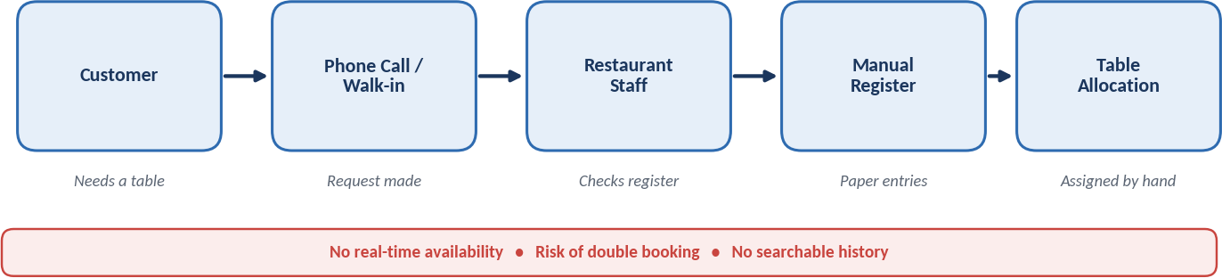
Figure A4. Existing manual reservation process
The manual process depends on a receptionist checking and writing a register, which explains the need for a shared digital source of truth.
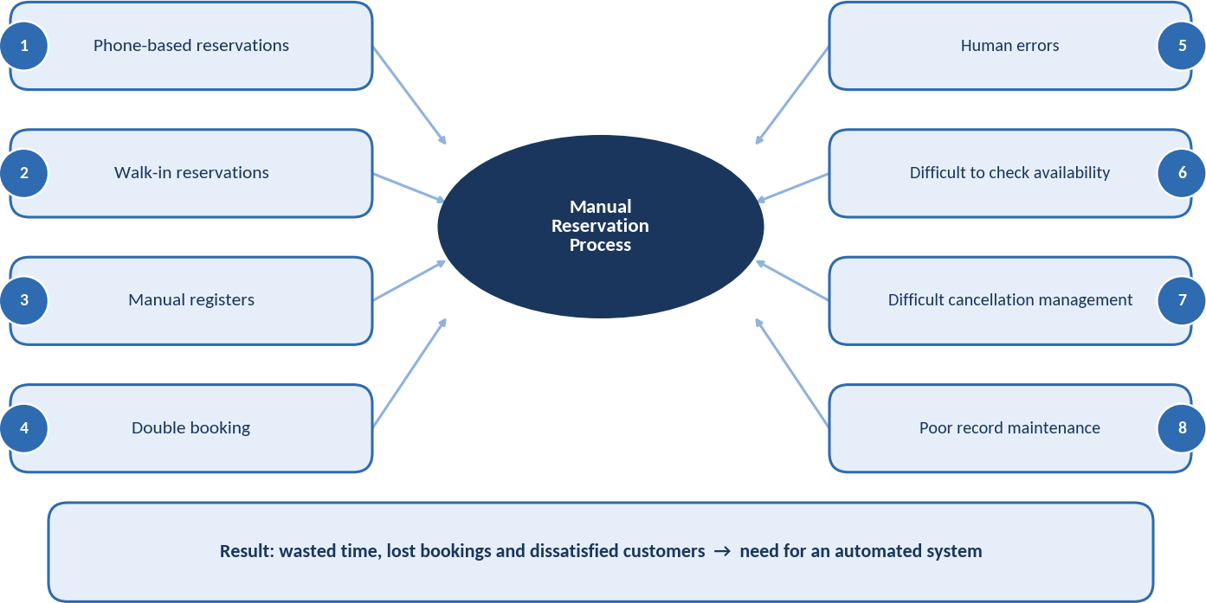
Figure A3. Problem analysis of the manual reservation process
The figure highlights how phone calls, walk-ins, manual registers, and human errors create double-booking and tracking risks.

A4. Existing System versus Proposed System
Existing system | Proposed system
Manual telephone or walk-in booking | Digital customer self-service booking
Difficult availability checking | Availability searched by date, time, and party size
Higher chance of duplicate entries | Conflict checks and transaction control
Paper registers | Centralized database records
Slow confirmation | Immediate reservation reference and status
Cancellation is difficult to track | Cancellation updates status and releases the slot
Limited reporting | Searchable booking history and reports

A5. Proposed System and Objectives
The proposed application has two main user roles. Customers register or log in, search by date and time, view suitable free tables, select a table, and confirm a reservation. Restaurant staff use a management portal to maintain table details and monitor, confirm, seat, complete, or cancel bookings. When a reservation is confirmed, the system stores the record, checks for conflicts, and updates availability for the selected time slot.
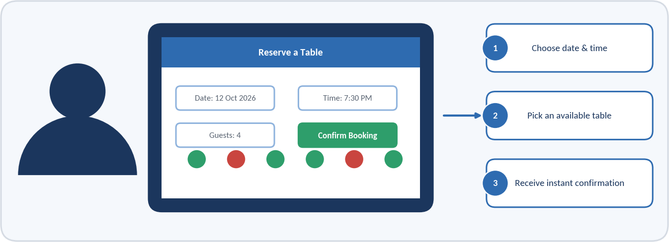
Figure A7. Customer reservation screen mock-up
This academic mock-up illustrates the expected customer-facing interaction without implying that a production interface has already been implemented.
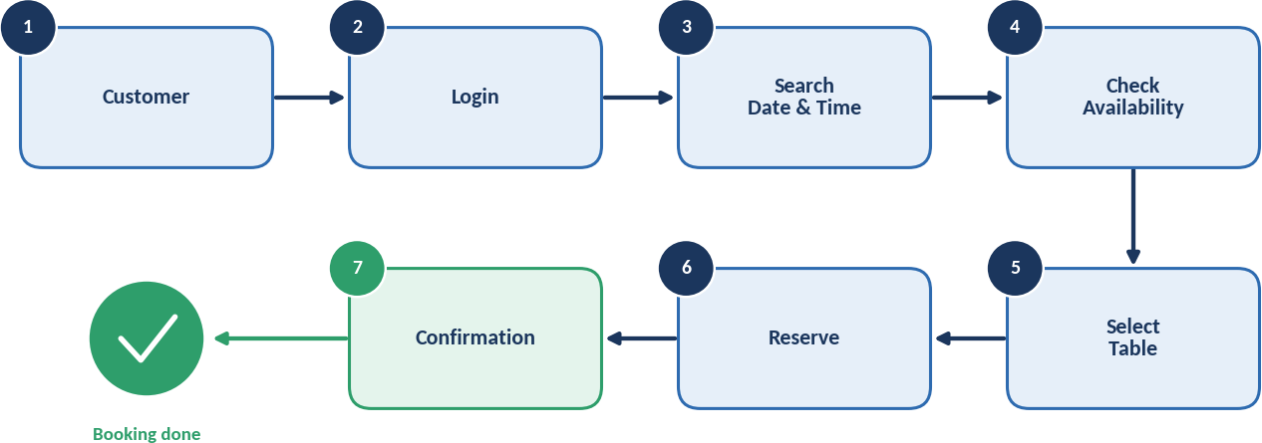
Figure A6. Customer reservation flow
The customer flow complements the acceptance criteria for search, table selection, reservation, and confirmation.
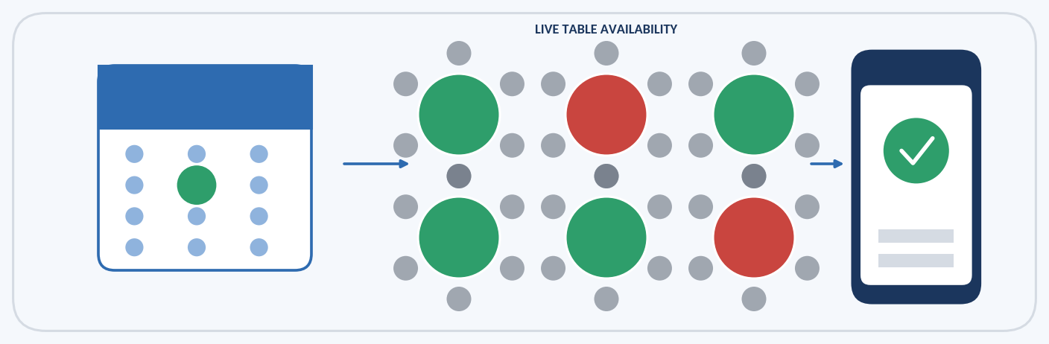
Figure A5. Conceptual view of live table availability
The illustration represents free, reserved, and selected tables as the customer moves from availability search to confirmation.
Objectives of the system:
- View table availability.
- Reserve tables.
- Cancel reservations.
- Manage restaurant tables.
- Manage bookings.
- Prevent double booking.
- Maintain reservation history.
- Reduce manual work.
- Improve customer experience.

A6. Requirements Analysis

Functional Requirements
ID | Functional requirement | Primary actor
FR1 | Register and log in securely. | Customer / Staff
FR2 | Search table availability by date, time, and party size. | Customer
FR3 | View table capacity, type, identifier, and status. | Customer / Staff
FR4 | Create a reservation for an available table. | Customer
FR5 | Display a unique reservation reference and confirmation. | Customer
FR6 | View reservation details and current status. | Customer / Staff
FR7 | Cancel a reservation according to the cancellation policy. | Customer / Staff
FR8 | Add, update, activate, or deactivate table records. | Staff
FR9 | Filter and manage bookings by date, time, status, and table. | Staff
FR10 | View customer and reservation history. | Staff / Manager
FR11 | Generate basic reservation reports for a selected period. | Manager

Non-Functional Requirements
- Performance: common searches should return results quickly under normal restaurant load.
- Security: authentication, role-based authorization, password hashing, HTTPS, and protected customer data must be used.
- Reliability: reservation transactions must prevent partial updates and double booking.
- Usability: customer and staff screens should use clear labels, validation messages, and familiar web-form conventions.
- Availability: the service should be accessible during restaurant operating and reservation hours.
- Scalability: the design should support more tables, customers, and restaurant branches in later releases.
- Maintainability: modules, APIs, and database structures should be documented and tested.

A7. Feasibility Study
Feasibility area | Assessment | Result
Technical | HTML, CSS, JavaScript, Java or Python, MySQL, a standard web server, and a modern browser are sufficient. | Feasible
Economic | Open-source tools reduce licensing costs; benefits include fewer lost bookings and less manual effort. | Feasible
Operational | Familiar web forms require little training and fit the restaurant’s existing booking process. | Feasible
Schedule | Analysis, design, implementation, testing, and deployment can be completed in approximately 12–14 weeks. | Feasible
Security | Authentication, authorization, HTTPS, password hashing, and backups can be implemented using standard practices. | Feasible

The feasibility assessment supports proceeding with the proposed solution. The Agile approach further reduces delivery risk by validating the core reservation flow in Sprint 1 before adding reporting, notifications, and advanced features.
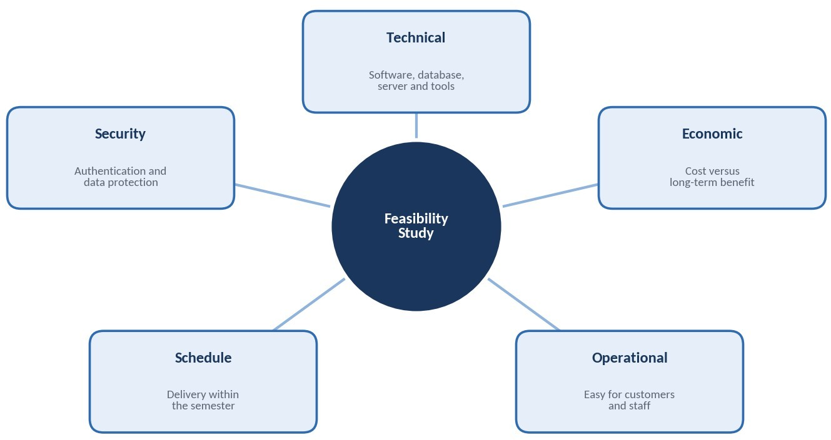
Figure A9. Feasibility overview
Technical, economic, operational, schedule, and security feasibility are all considered acceptable for the academic project.

A8. System Architecture and Use Cases
The system follows a three-tier architecture. The presentation tier contains customer and staff screens. The application tier validates requests, applies business rules, checks availability, creates or cancels reservations, and produces reports. The data tier stores customer, table, reservation, staff, payment, and audit information. Separation of concerns improves security, testing, and maintainability.
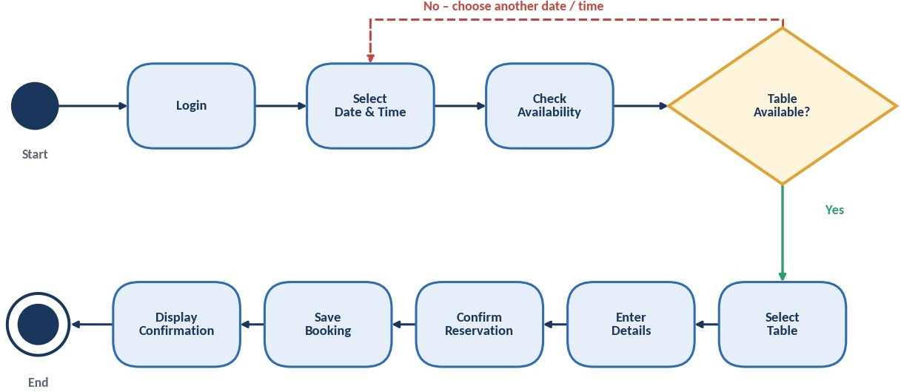
Figure A13. UML activity diagram for customer reservation
The activity flow includes login, date/time selection, availability checking, table selection, reservation confirmation, and the alternate conflict path.
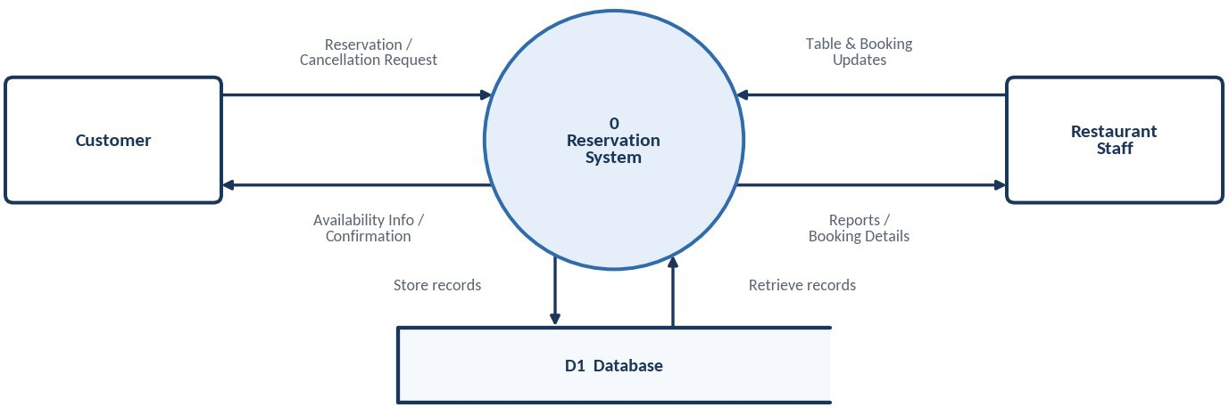
Figure A12. DFD Level 0 context diagram
The context view shows the reservation system exchanging availability, reservation, booking, and customer information with the main actors and database.
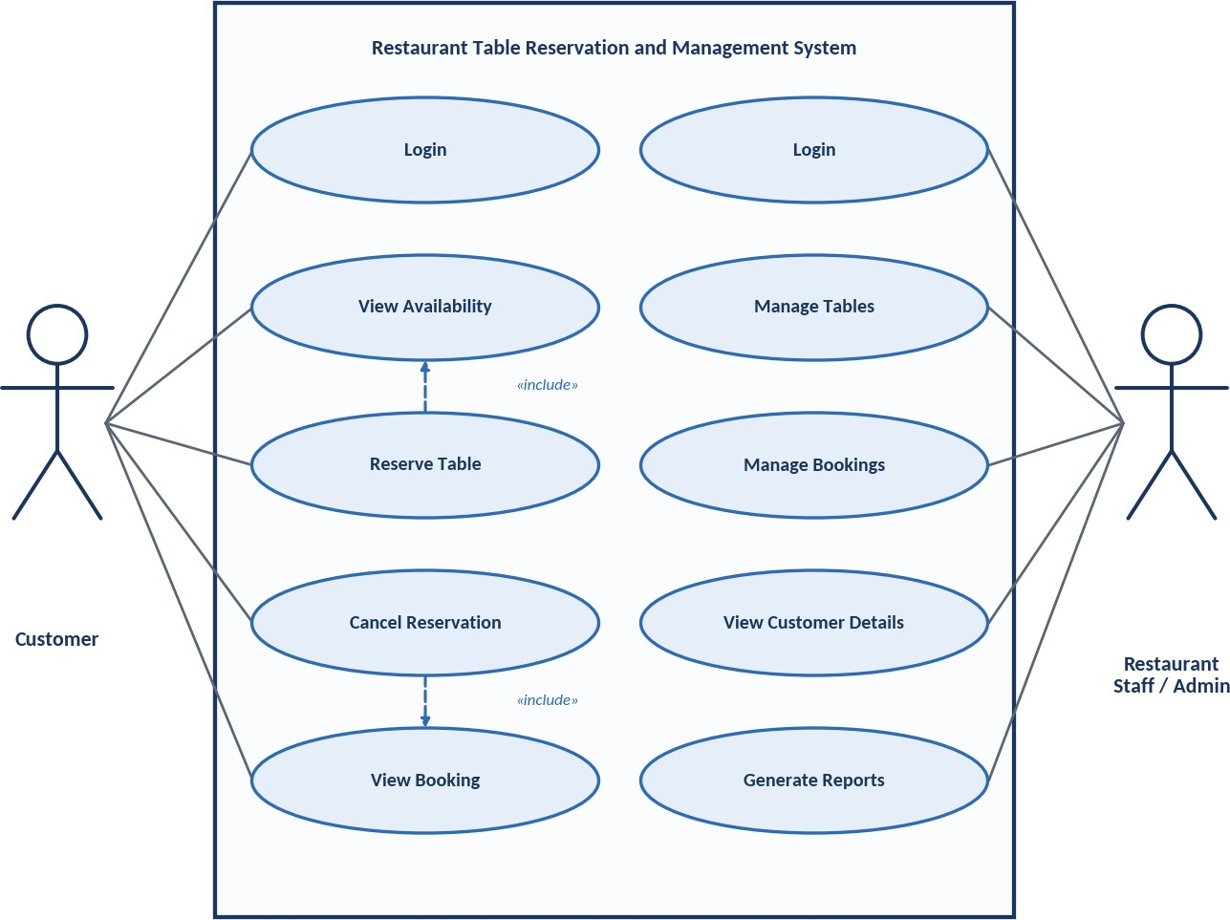
Figure A11. UML use-case diagram
The use-case view separates customer capabilities from restaurant staff/admin operations.
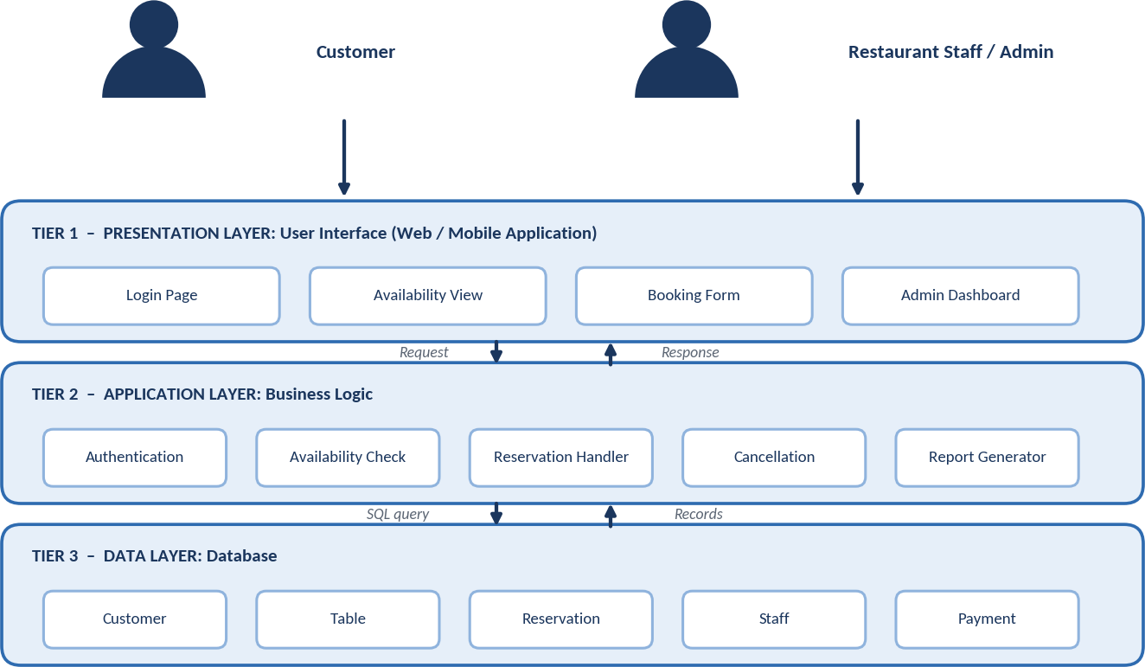
Figure A10. Three-tier system architecture from the reference
The presentation, application, and data tiers provide a clear mapping between user actions, business rules, and stored records.
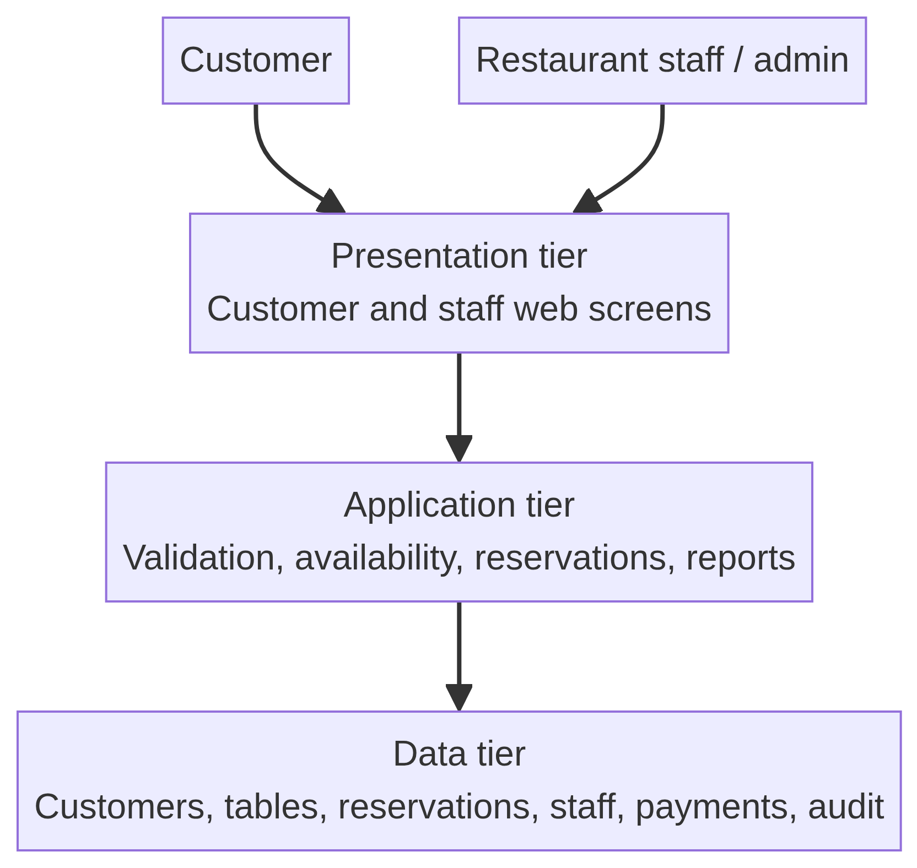
Figure A1. Three-tier architecture for the RTRMS
The main use-case actors are Customer and Restaurant Staff/Administrator. Customers register, search availability, view table details, reserve, view, and cancel bookings. Staff authenticate, manage tables, manage bookings, view customer information, and generate reports. The manager role inherits staff functions and adds oversight and reporting responsibilities.
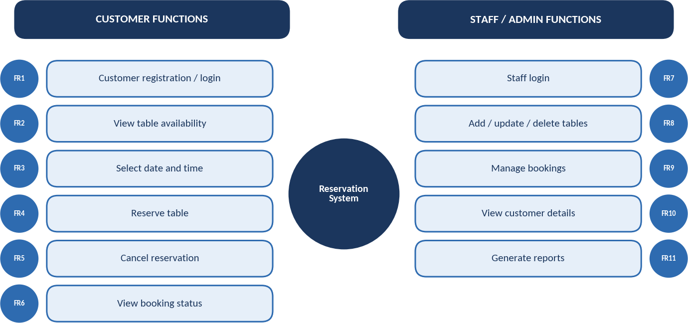
Figure A8. Functional overview by user role
The customer and staff/admin functions map directly to FR1–FR11 and the epics in the product backlog.

A9. Database Design
The relational database contains five core entities: CUSTOMER, RESTAURANT_TABLE, RESERVATION, STAFF, and PAYMENT. RESTAURANT_TABLE is used in the implementation instead of TABLE because TABLE is a reserved word in some SQL systems. One customer can make many reservations, one table can be booked many times in different time slots, and each reservation may have at most one payment record.
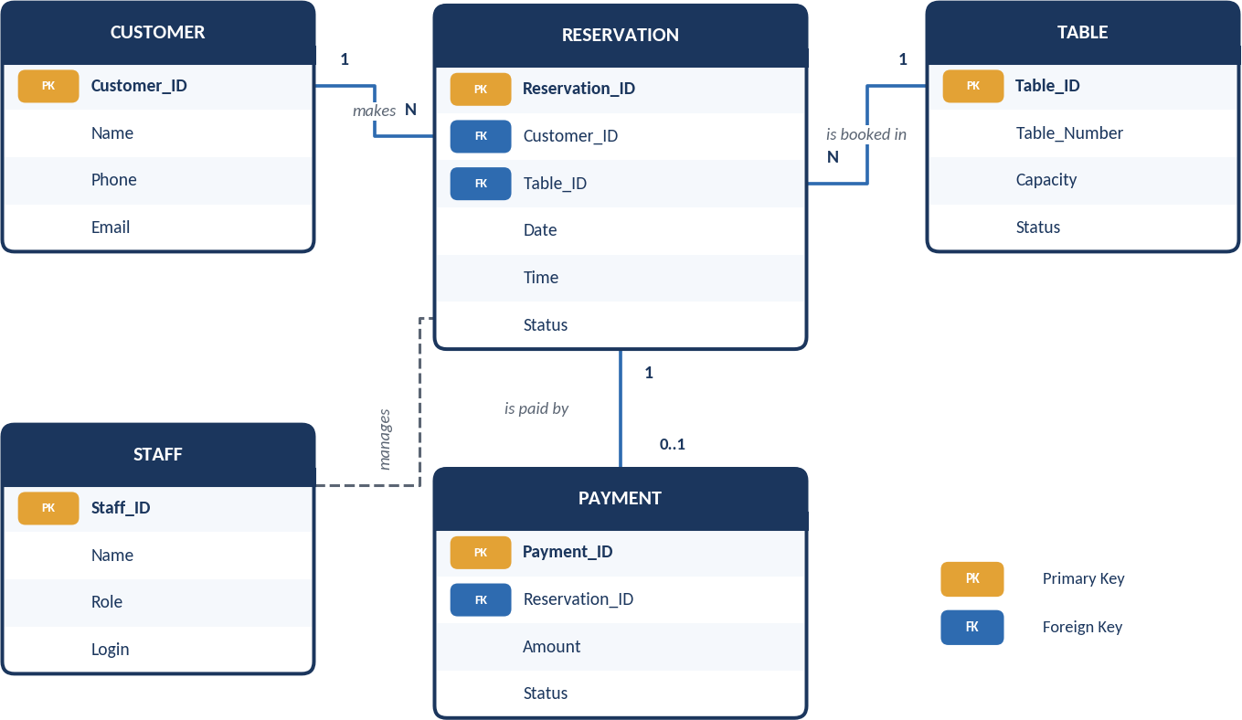
Figure A14. Entity relationship diagram
The ER model shows the relationships between customers, reservations, tables, staff, and optional payment records.
Entity | Important attributes | Primary key | Foreign key
CUSTOMER | Customer_ID, Name, Phone, Email | Customer_ID | –
RESTAURANT_TABLE | Table_ID, Table_Number, Capacity, Status | Table_ID | –
RESERVATION | Reservation_ID, Customer_ID, Table_ID, Date, Time, Status | Reservation_ID | Customer_ID; Table_ID
STAFF | Staff_ID, Name, Role, Login | Staff_ID | –
PAYMENT | Payment_ID, Reservation_ID, Amount, Status | Payment_ID | Reservation_ID

Integrity constraints
- Entity integrity: every entity has a unique, non-null primary key.
- Referential integrity: customer, table, and reservation foreign keys must refer to existing records.
- Double-booking control: an active reservation cannot duplicate the same table, date, and time slot.
- Domain integrity: status values are restricted to defined values such as Available, Reserved, Confirmed, Seated, Completed, and Cancelled.
- Auditability: important changes record actor, timestamp, action, and affected record.

A10. Major Modules and Complete Workflow
Module | Main responsibility | Related backlog stories
Customer Management | Registration, login, profile and reservation lookup. | US-04, US-08
Table Availability Management | Table capacity, status, operating slots, and availability rules. | US-01, US-02, US-06
Reservation Management | Create, confirm, view, and update reservations. | US-03, US-04, US-07
Cancellation Management | Validate policy, cancel booking, and release capacity. | US-05
Staff/Admin Management | Roles, permissions, and staff operations. | US-08
Database and Audit Management | Persistence, integrity, history, and audit records. | US-10
Report Management | Period-based booking and utilization summaries. | FR11 / future backlog

Complete reservation workflow: the customer logs in or enters booking details, searches for a date and time, views suitable tables, selects a table, submits customer details, and confirms the reservation. The system validates the request, performs an atomic conflict check, stores the reservation, updates the slot status, displays the reservation reference, and queues a notification. Staff can later confirm, seat, complete, or cancel the booking according to policy.
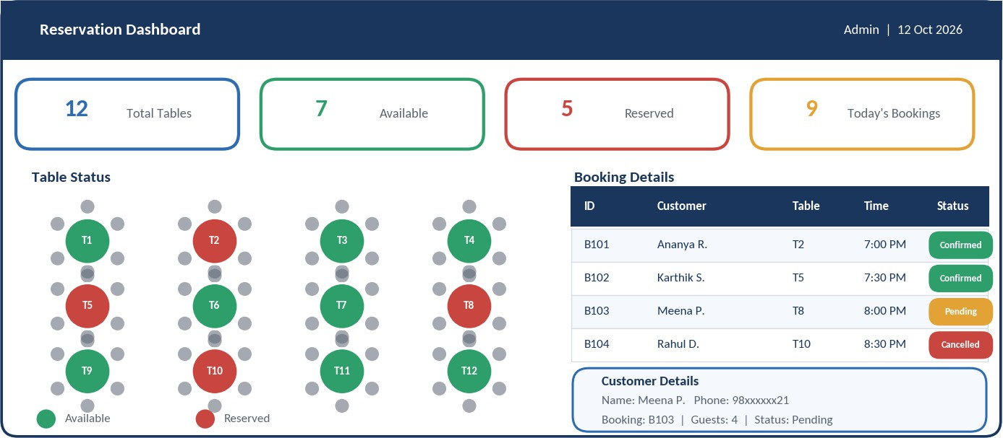
Figure A16. Restaurant reservation dashboard mock-up
The dashboard illustrates the staff view of table status, booking records, customer details, and reservation status.
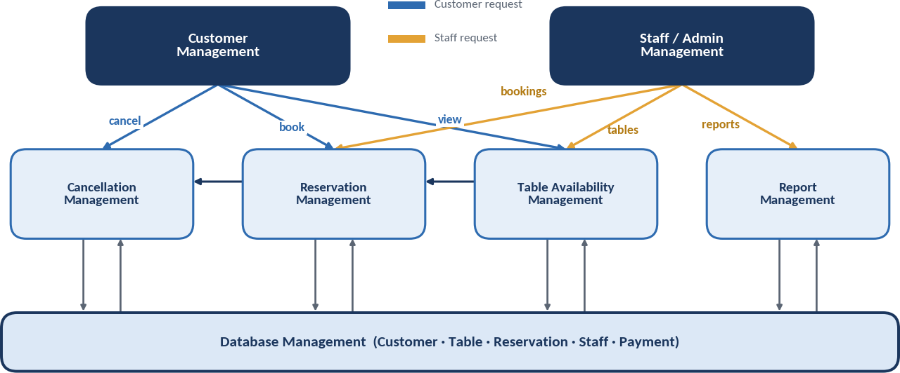
Figure A15. Module interaction diagram
The modules provide a traceable link between customer management, reservation management, table availability, cancellation, reporting, and database management.
Figure A2. Complete reservation workflow

Testing Strategy and Test Cases
Testing is performed at unit, integration, system, usability, security, and acceptance levels. Defects are logged, fixed, and re-tested. The following cases connect directly to the acceptance criteria in the Agile backlog.
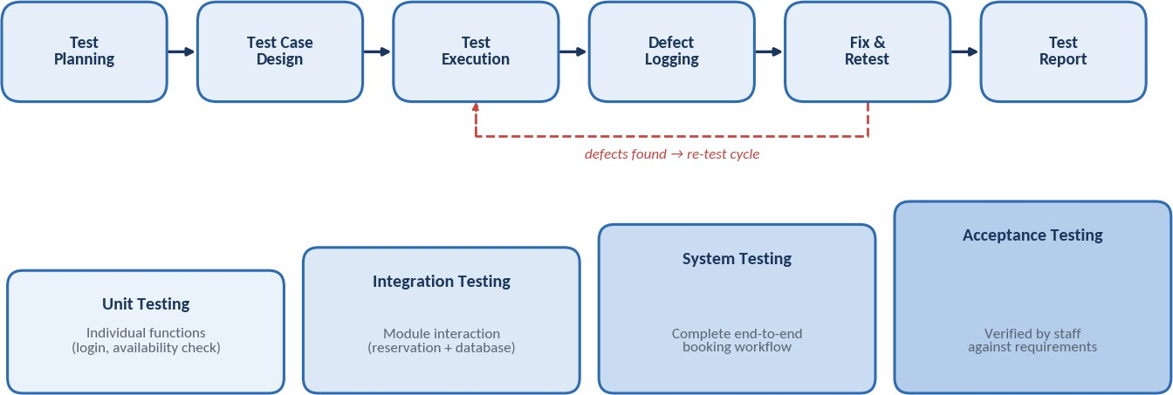
Figure A17. Testing process and test levels
Testing begins with planning and case design, proceeds through execution and defect logging, and ends with re-test and reporting across unit, integration, system, and acceptance levels.
Test ID | Test scenario | Expected result
TC01 | Customer logs in with valid credentials. | User is authenticated and the home page opens.
TC02 | Login uses an incorrect password. | Error message appears and access is denied.
TC03 | Customer searches a valid date, time, and party size. | Suitable free tables are displayed.
TC04 | Customer reserves an available table. | Reservation is saved and confirmation is shown.
TC05 | Customer attempts to reserve a table already booked for the same slot. | Booking is rejected and double booking is prevented.
TC06 | Customer cancels an existing reservation. | Status becomes Cancelled and capacity is released.
TC07 | Staff adds or updates a table. | Table record is validated and changed in the database.
TC08 | Staff views booking and customer details. | Correct details are displayed according to permissions.
TC09 | Manager generates a reservation report. | Report is produced for the selected period.
TC10 | Customer submits a form with empty required fields. | Validation messages identify the missing fields.

Advantages, Limitations and Future Scope
Advantages: the system provides faster reservations, accurate availability, reduced staff workload, lower double-booking risk, searchable records, and better customer confidence through confirmation and cancellation status.
Limitations of the first release: it assumes one restaurant branch, depends on configured operating hours and table rules, may require an external notification service, and does not initially include online payments, loyalty, delivery ordering, or advanced demand forecasting.
Future enhancements: online payment or booking deposits, SMS and e-mail reminders, a mobile application, wait-list management, table-combination rules, multi-branch support, customer loyalty, analytics, demand forecasting, and integration with point-of-sale systems.
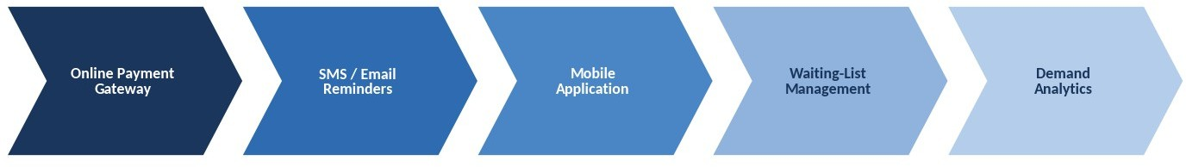
Figure A18. Future enhancement roadmap
The roadmap places online payment, mobile access, notifications, waitlist management, and demand analytics after the stable core reservation release.

References
[1] I. Sommerville, Software Engineering, 10th ed., Pearson, 2016.
[2] R. S. Pressman and B. R. Maxim, Software Engineering: A Practitioner’s Approach, 9th ed., McGraw-Hill, 2020.
[3] R. Elmasri and S. B. Navathe, Fundamentals of Database Systems, 7th ed., Pearson, 2016.
[4] G. Booch, J. Rumbaugh, and I. Jacobson, The Unified Modeling Language User Guide, 2nd ed., Addison-Wesley, 2005.
[5] ISO/IEC/IEEE 29148:2018, Systems and Software Engineering – Life Cycle Processes – Requirements Engineering.
Agile activities applied to this project:

